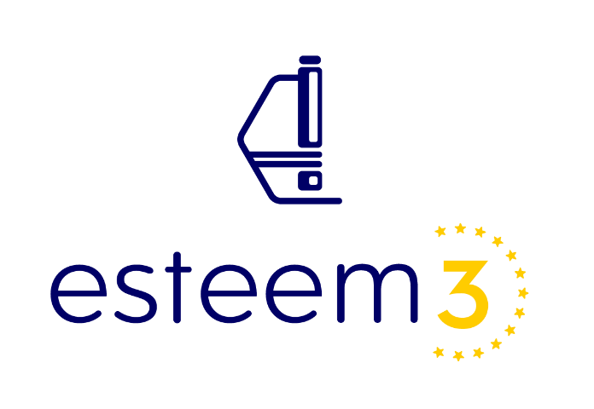

Request for Transnational Access

ESTEEM3 aims at providing Transnational Access (TA) to the leading European state-of-the-art Transmission Electron Microscopy (TEM) research infrastructures, facilitating and extending TA services of the most powerful atomic scale characterization techniques in advanced electron microscopy research to a wide range of academic and industrial research communities for the analysis and engineering of novel materials in physical, chemical and biological sciences.

ESTEEM3 TA providers’ grant access free of charge at point of use to their installations to selected user groups (i.e. teams of one or more researchers led by a ‘user group leader’), in which the user group leader and the majority of the users work in a country other than the country where the installation is located. Only user groups that are allowed to disseminate the results, they have generated under the action, may benefit from the access, unless the users are working for SMEs. Access for user groups with a majority of users not working in an EU or associated country is allowed, but limited to 20% of the total amount of units of access provided under the grant.

Selection procedure:
The user groups must request access by submitting (in writing) a description of the work that they wish to carry out and the names, nationalities and home institutions of the users. The user groups are then selected by the TAPEC (Transnational Access Proposal Evaluation Committee), which is composed of renowned scientists in microscopy and materials science, not associated with the project to ensure transparency. To avoid potential conflicts of interest, the TAPEC members reviewing proposals will neither come from the country of the applicant nor the TA provider.

Each proposal will be assessed by the TAPEC against the following selection criteria:
• Scientific quality of the proposal (rank: weak: 0 – outstanding: 10)
• Demonstration of the need for the use of the advanced infrastructure (rank: weak: 0 – outstanding: 5)
• Potential impact for academic or industrial innovation (rank: weak: 0 – outstanding: 5)
Proposals with a total ranking less than 10 will be rejected.

Prior to assessment by the TAPEC, the TA provider will assess the feasibility of the experiment as well as all possible related safety and environmental issues. Proposals, that do not meet the requirements of the TA provider, will be rejected and may be transferred to an alternative TA provider. In the case of open proposals, the TA provider will be selected by the Project Coordinator.

Open Proposal form

Title of the proposal:

Acronym of the proposal:

Identify and describe the samples you want to study (1000 characters maximum, pictures allowed).

What is the state-of-the art in the study of these materials (2000 characters maximum, pictures allowed)?

What problem do you want to solve (2000 characters maximum, pictures allowed)?

What is the potential for academic or industrial innovation?

Number of access requested:

Number of samples to be prepared by the ESTEEM3 provider:

Note: TEM and Data Analysis days will be granted by the TAPEC.

Do you wish to come at the ESTEEM3 center while the experiment is carried out?
☐ No, we will only send the samples
☐ Yes, please specify why

